**SNIA User Documentation**

**1) Introduction**………………………………………………………………………………………………………… **2**

1.1. Purpose………………………………………………………………………………………………….2

1.2. Overview ……………………………………………………………………………………………….2

**2)** **Main Dashboard**…………………………………………………………………………………………………… **2**

2.1) Source URL’S for swordfish Main Dashboard ……………………………………………………… 3

2.2) Child Dashboard URL’S for swordfish Main Dashboard

2.2) Swordfish Storage services………………………………………………………………………………….. 3

2.3) Navigated URL’S of Swordfish storage services……………………………………………………. 3

2.4) All storage Pools capacity data…………………………………………………………………………….... 4

**3)** **Child Dashboard**…………………………………………………………………………………………………….. 4

3.1) Count of Storage services_1 (volumes and Storage Pools)……………………………………. 6

3.2) Consumed capacity of volumes and Storage pools……………………………………………….. 6

3.3) Usage of volumes and Storage Pools Capacity……………………………………………………….. 6

# 1. Introduction

## Purpose

The purpose of the User specification document is Power-Bi dash board Explanation.

## Overview

## Power BI is a suite of business analytics tools to analyze data and share insights. Power BIdashboards provide a 360-degree view for business users with their most important metrics in one place, updated in real time, and available on all of their devices. With one click, users can explore the data behind their dashboard

## 2. Main Dashboard

The main dashboard shows count of all swordfish Services , all storage pools consumed capacity based on allocated capacity and child dashboard navigated URL’S .

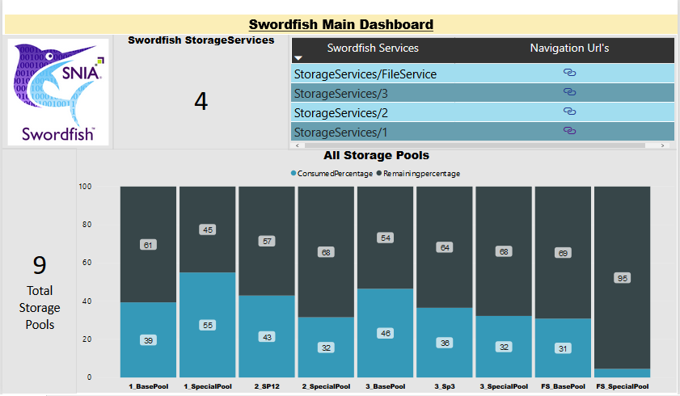

Fig: - Main Dashboard

## 2.1) Sample Source URL’S for Swordfish Main dashboard:-

<http://localhost:5000/redfish/v1/StorageServices/1>/StoragePools

<http://localhost:5000/redfish/v1/StorageServices/2>/StoragePools

<http://localhost:5000/redfish/v1/StorageServices/3>/StoragePools

<http://localhost:5000/redfish/v1/StorageServices/FileService/StoragePools>

## 2.2) Sample Source URL’S for Swordfish Child-dashboard:-

<http://localhost:5000/redfish/v1/StorageServices/1/Volumes>

<http://localhost:5000/redfish/v1/StorageServices/1/StoragePools>

2.3) Swordfish StorageServices : -

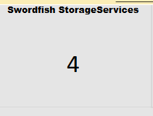

The above figure shows the count of all Swordfish storage services

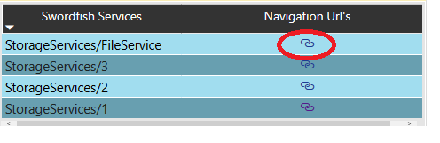2.4) Navigated URL’s of Swordfish storage services: -

The above Figure shows the all Swordfish Navigated URL’s

Note: When we click on the Highlighted Navigated URL it goes to child dashboard

2.5) All storage Pools capacity data :-

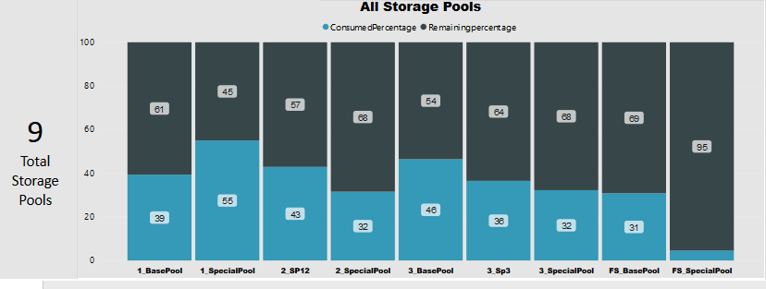

The swordfish storage services of all the storage pools merged into one place and shown the consumed capacity percentage out of allocated percentage.

Note: -After clicking the Navigated URL’s, it will go to Child-dashboard.

3) Child Dashboard: -

In the child dashboard shows the Count of Storage Services (volumes, filesystems and Storage Pools) and Consumed capacity based on Allocating capacity.

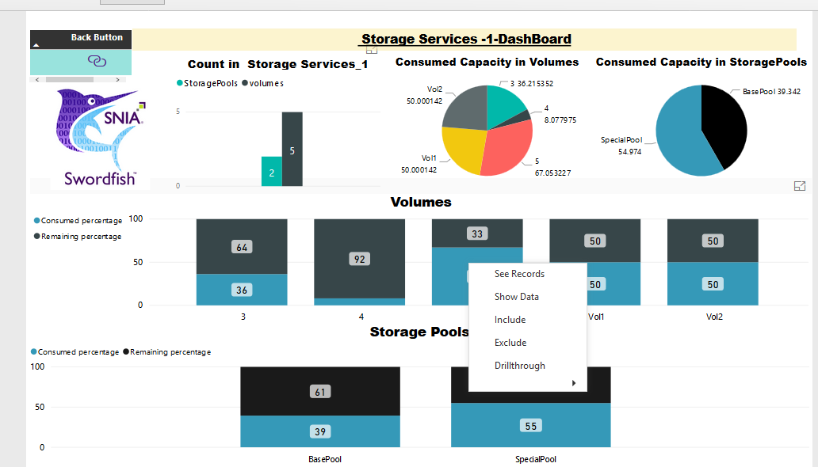

Fig: -Child Dashboard

When user wants threshold of each volume separately Right click on any volume and click the “Drill through” tab as shown in the above figure .

3.1) Count of Storage services-1(volumes and Storage Pools): -

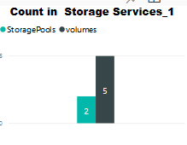

The above figure shows the count of volumes and storage pools using Bar-chart

3.2) consumed capacity of volumes and Storage pools:-

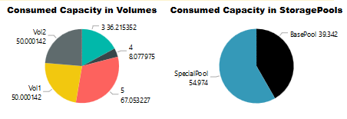

The above figure shows the consumed capacity of volumes and Storagepools in Storageservices_1 by using pie chart.

3.3) Usage of volumes and Storage Pools Capacity:-

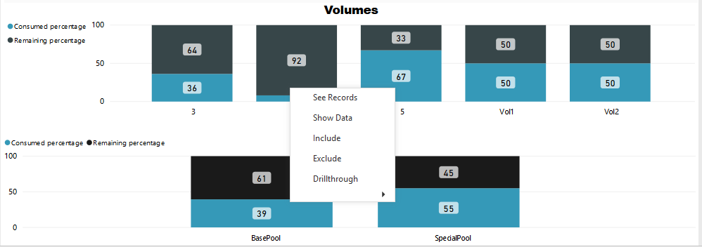

When we want thresholds for each one separately, we can right click on the volume as shown in the above figure and will get the below page.

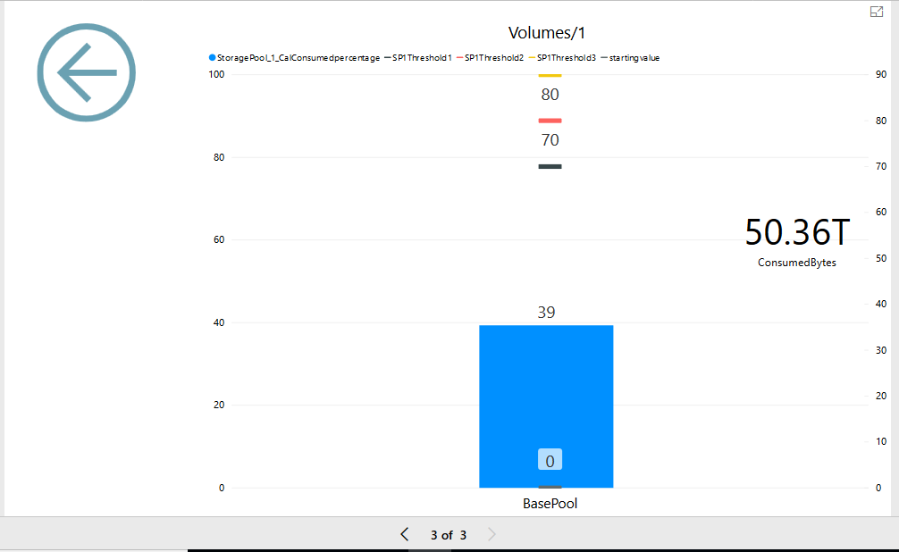

* The color lines show the different threshold values and the filled color shows the consumed percentage of selected Drill through service.
* The right side shown usage of Consumed capacity in Terabytes
* When user want to Navigate main Dashboard again can click on the Back Button as shown below figure .



For all the swordfish storage services sub dashboards shows same diagrams but the data changes when user changed in web- client or Emulator.